Lab F

Brandon Trinkle

Arizona State University

Course Number: IFT 202

Professor Gary Grindle

Feb 10, 2024

Part 1

Task 1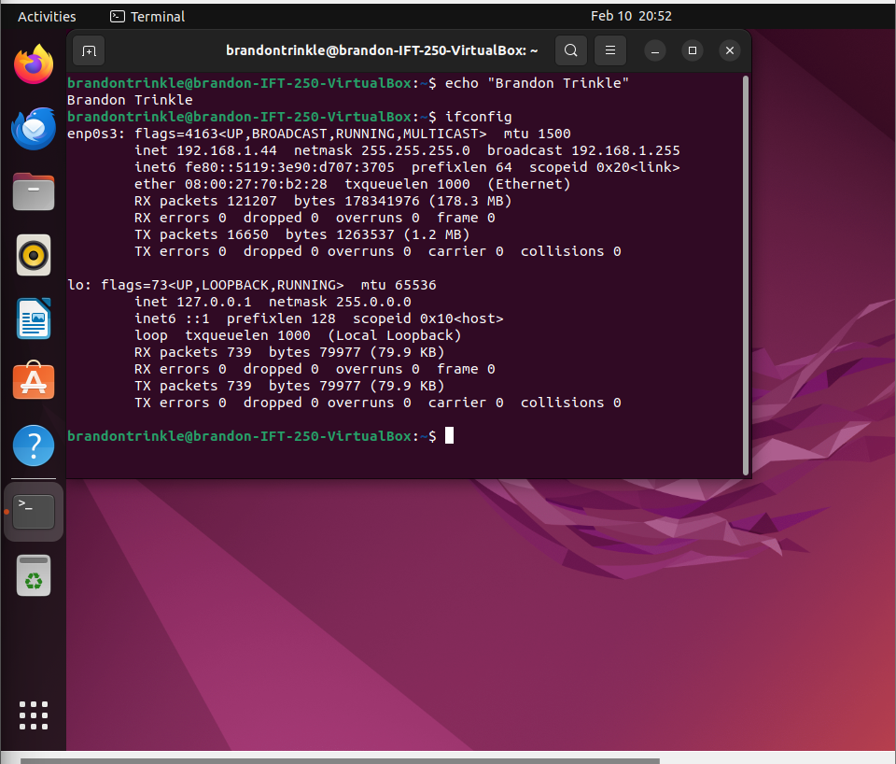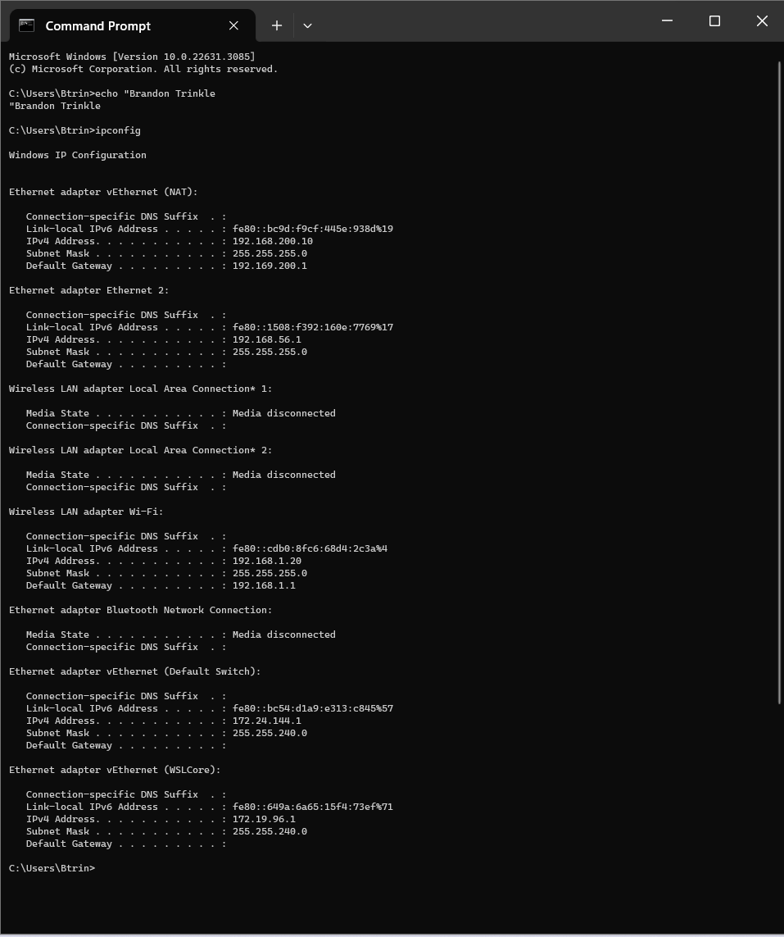

Task 2

Task 3

Task 4

Task 5

Task 6

Task 7